28.38: Outside a toroidal solenoid there is no magnetic field and inside it the magnetic field is given by 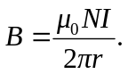
a) r = 0.12 m, which is outside the toroid, so B = 0.
b) r = 0.16 m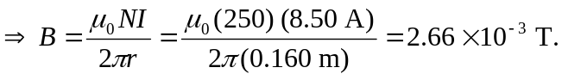
c) r = 0.20 m, which is outside the toroid, so B = 0

